**Assignment ODE**

Gasification of a carbon particle: 2 C + O2 -> 2 CO

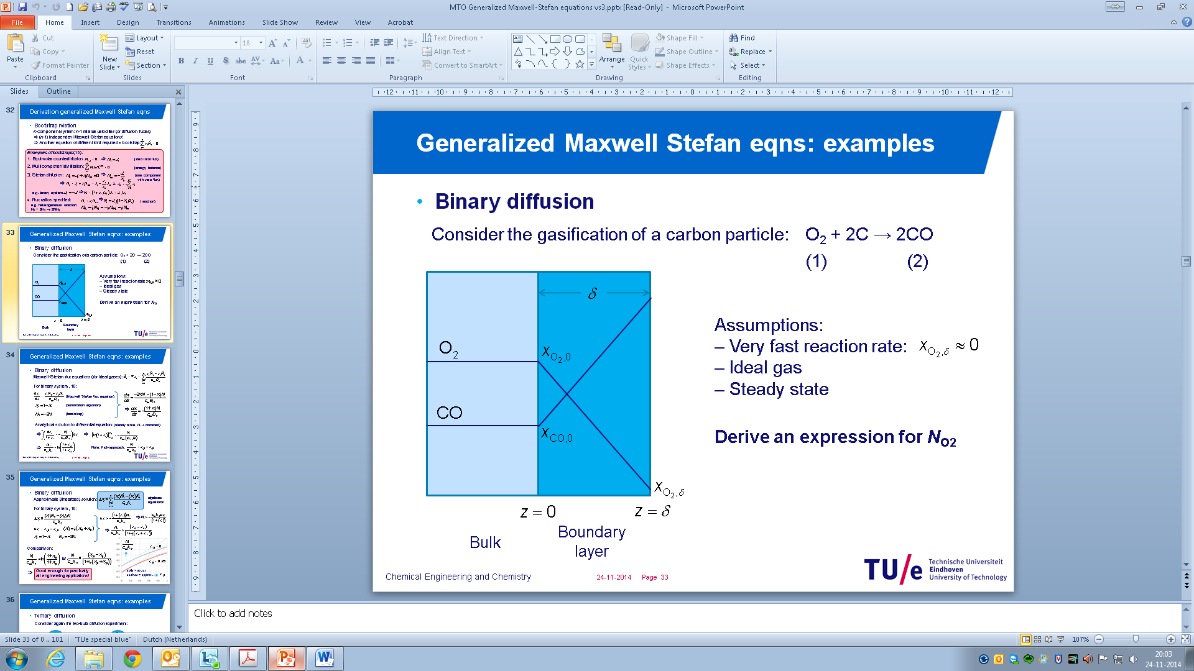

Assume: i) very fast reaction so that $x_{O_{2},δ}≈0$; ii) ideal gas; iii) steady state (decrease in particle size goes much slower than establishing of the concentration profiles;

Application of the Maxwell-Stefan equations for multi-component mass transfer yields (using 1 and 2 to denote O2 and CO respectively:

$$\frac{dx_{1}}{dz}=-\frac{\left(1+x_{1}\right)}{c_{tot}D_{12}}N_{1}$$

With the boundary conditions: $x_{1}\left(z=0\right)=x_{1,0}=0.2$ and $x_{1}\left(z=δ\right)=0$ (very fast reaction)

*P* = 1 atm; *T* = 873 K; *D12* = 1.6·10-3 m2/s, δ = 1.0·10-3 m

1. Solve this boundary value problem and calculate the O2 mole flux using the Maxwell-Stefan approach
2. Compare with the analytical solution by integrating the equation analytically
3. Compare the O2 mole flux with the Fickian approach and explain your result.

**Answers:**

1. *Ctot* = P/RT = 101325/8.314/873 = 13.96 mol/m3

⇒ *N*1,numerical = 4.0687 mol/m2s (when using first order explicit Euler with 100 steps)  
  *N*1,numerical = 4.072028 mol/m2s (when using first order explicit Euler with 1000 steps)  
  *N*1,numerical = 4.072402 mol/m2s (when using fourth order explicit RK with 100 steps)

1. Analytical solution: $\int_{x_{1,0}}^{x_{1},δ}{\frac{dx_{1}}{1+x_{1}}}=-\frac{N_{1}}{c_{tot}D_{12}}\int_{0}^{δ}{dz}$ ⇒ $N_{1}=k_{12}c_{tot}\ln\left(\frac{1+x_{1,0}}{1+x_{1,δ}}\right)$

⇒ *N*1,analytical = 4.072399 mol/m2s

1. Fick approach: $N_{1}=k_{12}c_{tot}\left(x_{1,0}-x_{1,δ}\right)$  
   ⇒ *N*1,analytical = 4.467271 mol/m2s

Fick overpredicts the flux, because there is a net drift flux from the surface (in the negative z-direction) because 2 CO molecules move from the interface per 1 O2 molecule moving towards the surface. This negative drift-flux decreases the actual O2 flux towards the surface, which is properly accounted for in the Maxwell-Stefan theory, but ignored in the Fickian approach.